BANK

HOMEWORK 4

Tatar Mara
30425

Abstract
TP Lab –Homework 4
Objective
Design by Contract Programming Techniques
Description
Consider the system of classes in the class diagram below.
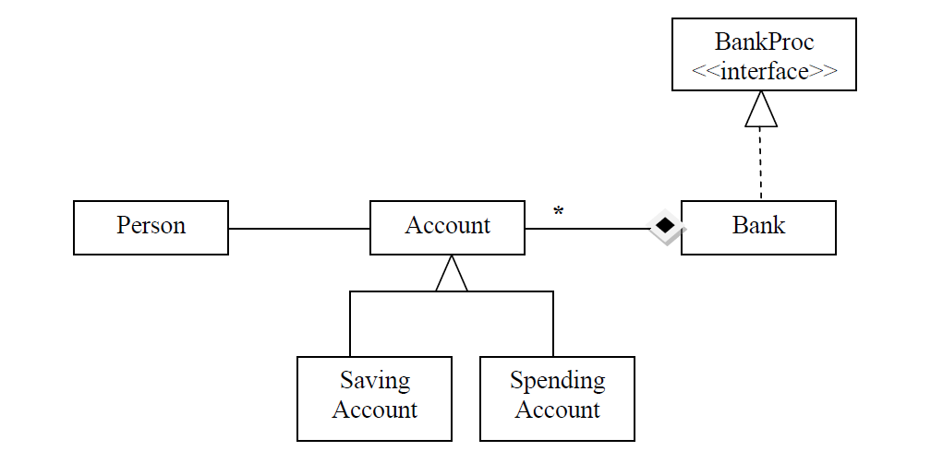

1.Define the interface BankProc (add/remove accounts, read/write accounts, report generators, etc). Specify the pre and post conditions for the interface methods.
2. Implement the classes Person, Account, SavingAccount and SpendingAccount. Other classes may be added as needed. Please justify.
3. Implement the class Bank using a hashtable. Chaining will be used in case of collisions.
3.1 Define a method of type “well formed” for the class Bank.
3.2 Implement class using Design by Contract method (involving pre, post conditions, invariants, assertions).
4. Populate the Bank with Account objects. The account data will be taken from a file.
5. Implement a user guided test driver for the system.

Project Specifications:

This application has to model the working regime of a bank and the way that bank accounts are handled. The application should contain minimally the following classes:
Person, Account, Bank, SpendingAccount, SavingAccount. The class bank should contain a hash table. The should be serialized in bank.ser. The class bank should be implemented using the design by contract method, each of the methods defined having pre and post conditions. The application should also have a user interface that would allow an easier way of interacting with the software. Furthermore, the application should display the data in a table for a better view.
The application that I have developed fulfills the requirements listed above. It implements the required classes along with other classes that are needed. Moreover, it uses a graphical user interface composed of several buttons, text fields, a menu, a text frame to display report, two tables to display the information processed. The application reads the initial data from a text file,bank.ser. So this way the bank is populated with accounts when the program is ran. Besides this, the user can introduce new accounts or modify the existing ones. The user can also delete an account.
When introducing a new account the software checks if the account is valid and if not gives an error message. Implementing the bank as a hash table, the searching and introducing operations can be done in O(1), constant time, so the efficiency of these operations is high.
The program also uses JUnit for a test case. This way the basic operations such as introducing new accounts, deleting an account ,introducing a person or deleting one are rigorously tested. Other tests were also performed, but by taking some test cases and performing them by a human user. These tests also consisted of adding new accounts, deleting accounts, searching accounts after some special criteria, extracting money from accounts or adding money to accounts. There are also some other test cases performed to check the stability and the efficiency of this software.

Design

1. Data structures:
In order to model the real world in this simulation the abstracting process was used. First of all we have to identify the classes involved in this application. As the requirements say, there are classes for Person, Account, Spending Account, Saving Account, Bank. Furthermore, the Accounts kept in the Bank should be stored in a hash table. To accomplish this task, a hash table was created.Besides the hash table, other structures as Array Lists were used to hold temporary data. To place data in the table, a table model was used. In this structure were introduced the required fields.
a)Use case 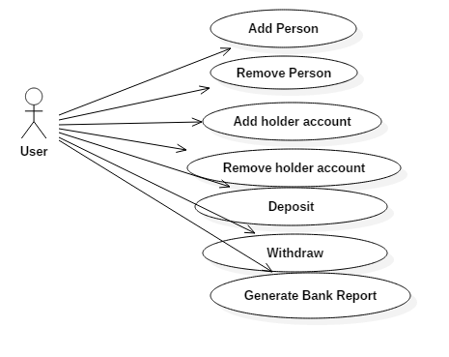

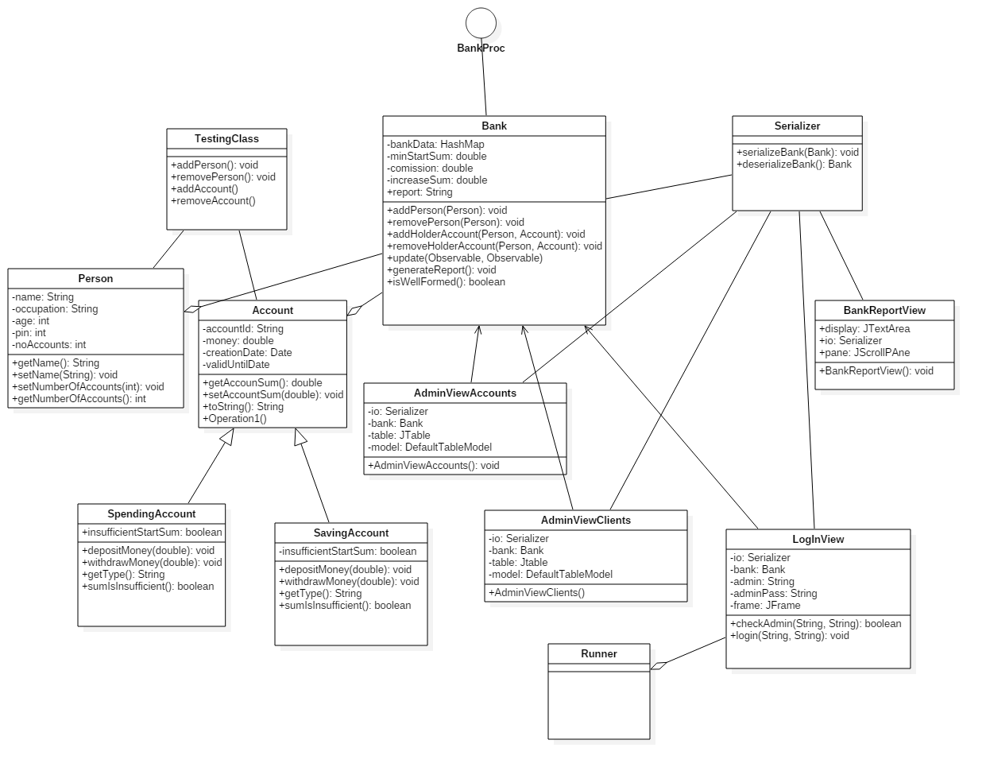

b)Class diagram
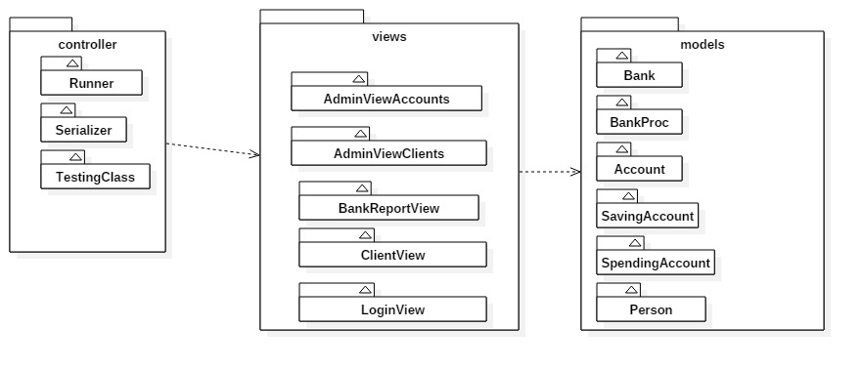

c)Package diagram
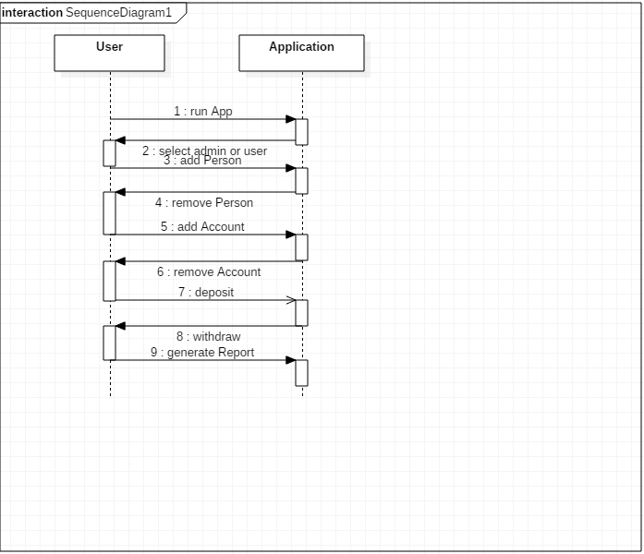

d)Package diagram
3. Classes:

The application implements several classes.
To begin with, the class Person represents the entity of a person that goes to the bank. It contains the basic information needed to know about a person who opens a bank account, like name, last name, age, address, occupation. The fields being private to fulfill the encapsulation, setter and getter methods were defined. Also, a toString method was defined for a string representation of the customer.
The class Account represents the entity of an account. It contains the owner of the account. Besides this, it contains a bank account number, the unique identifier to identify the account, and the amount of money deposited in that account. Furthermore, it overrides the equals method and the hash Code method of the class Object, to be able to be introduces in the hash table.
The class Spending Account simulates a appending account. It has inherits from the class Account and adds some specific methods, like methods to extract money from the account.
The class Savings Account represents a saving account and has some special methods to perform the actions required by an account of this type. It has methods to simulate the extraction and the addition of large amounts of money as well as computing the interest. It inherits from the class Account.
The class Bank contains a hash table that stores the accounts. The hash contains the specific functions needed to add, remove, search elements in the hash table.
It has some special search functions that perform the search of an element of the table after some special fields as the user desires.
The class Bank also implements an interface BankProc that declares the most important methods used by this class.
The class Interface contains the user interface. It is composed of a few text fields to fill the information about the account, some buttons to choose the desired actions, a jmenu bar to choose some additional actions, and a table to display the accounts. The class contains calls to other methods from the classes mentioned above. The class contains special methods to read data from a file and to create bank accounts from that data. It also uses methods to display information in the table.
The class IOClass contains static methods that allow to write and read a serializable object from and to a file.
The class Start contains the main method to run the program.

4.Relations

There are several relation that can be found in the architecture if this project.
To begin with, the relation of inheritance is shown by the classes Account, Saving Account and Spending Account. The latter classes inherit from the class Account. They add some new functionality to this class.
The class Bank contains several Accounts so the relation of aggregation is shown here. Furthermore, polymorphism is represented by the fact that Objects of type Account are instantiated as subclasses of this class, Spending Accounts or Saving Accounts.
The object of type Account has a Person, so the relation between them is of association.
The relation between the classes Interface and Bank is of association. The relation between the classes Start and Interface is of association.

Furthermore, the inheritance is shown by the fact that several classes inherit from JFrame.

5.Algorithms:

The program contains some basic algorithms.
One of the most important algorithms are those used to implement the hash table. The hash table solves collisions by chaining, as the problem requires. So, it is made of an array of lists. The hash function used is quite simple, key mod N. N is the size of the array. It should be a prime number so that the remainders are spread evenly through the table. This way, searching and inserting operations can be done in the best case in constant time and in worst case in linear time, that is quite bad in the case of hash tables. Each element introduces in the hash table has a pecial hash code. This code, or key, is taken by the hash function and reduced to the interval 0…N-1. Then, in the case of introducing a new entrance in the table, it checks all the elements in the list located at that position in the hash table to see if there is another element with the same unique code. If it does not find any duplicates, it introduces the element in the table. Otherwise, it sends a message. The algorithm to search an element after its key goes the other way. It computes with the same hash function the position in the hash table where the element should be. Then, it goes through the linked list located at that position in the hash table and compares each element until it finds one that matches the required key. If none of the elements match that key, there is no answer returned. This search algorithm shows the importance of spreading as evenly as possible the elements in the hash table. If the elements are evenly distributed, the search operation does not have to go through long lists when searching for elements, so the searching time is minimized.
The program also has some decision algorithms used when calling different functions. It also has a more complex algorithm of breaking a string in several substrings containing data needed to create an account. This algorithm is used together with the algorithm used to read data from a file and populate the bank with accounts of the two types already mentioned: saving and spending.

6.User Interface:

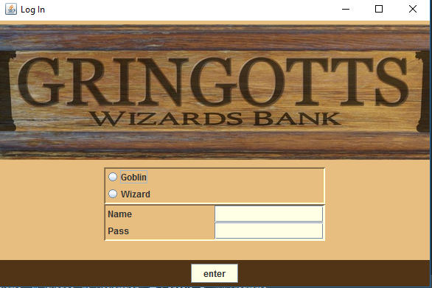

The software developed has a user friendly interface composed of :
A main window with the following components:
1. a menu with the following components:
- Create Spending Account
- Create Saving Account
- Save Accounts
- Exit
2. label Person last name
3. text field to introduce last name
4. label Person first name
5. text field to read first name
6. label job
7. text field to read job
8. label amount
9. text field to read amount
10. label number
11. text field to read number
12. label address
13. text field to read address
14. button search accounts
15. button add money
16. button extract money
17. button delete accounts
18. text area to display message
19. table to display accounts.

The components are displayed on a panel using the GridBagLayout. This panel is than added on the frame.

Implementation:

The program is written by implementing the classes already described. In each class there are implemented methods using the algorithms already described shortly.
The classes are made public. Most of the fields declared in each class are made private. So to access them from other class setter and getter methods were defined. The class IOClass contains only static methods so they can be called without having an object of type IOClass.

8.Class Start
  - public static void main(String[] args) – main method executed first when launching the application.

Testing

To test the application were considered several test cases.:

- Introduce invalid or no data:

The program runs without problems. For the fields that have no data or incorrect format, the program uses some default values, null or 0 so the order is not processed
The same happens if a account is introduced with invalid data.

- Introduce wrong parameters at search.

The software takes default values for the parameters that do not fulfill the hypothesis.

- Introduce two accounts with the same account number.

The software does not introduce the second account in the hash table.

All these tests fulfill the specifications. In this test plan with these test cases no error is encountered.

Results:

The software developed fulfills the specification described above and shows a basic method of handling and processing accounts in a bank. The software also contains a user interface and a method of reading from a file accounts at the beginning of the execution. Because of this, the interface can be used just to process the accounts and modify or search them.

Conclusions:

Even though at first sight the program performs, further testing should be taken. There also should be implemented a way of dealing with bank accounts and ways of paying. There also should be used a better graphical interface and some searching options for the persons.
Besides all these, a better distinction between the two bank accounts should be made according to their special definitions. New ways of interacting with the software should be developed to use its full functionality. Furthermore, more searching options should be made and also an administrator and user mode should be implemented.

